Snowflake Cost & Billing - Cost Management
1.Snowflake Pricing Overview:
Pay only for what you use — Compute charges stop when warehouse suspends; storage is compressed and charged monthly.
There is no fixed monthly bill like traditional databases
Three Pricing Components
Component | Unit | What It Covers
Compute | Credits/hour | Virtual warehouse query processing
Storage | $/TB/month | Tables, Time Travel, Fail-safe
Data Transfer | $/GB | Cross-region/cloud data movement

2. Credits Explained
- 1 Credit = ~$2-$4 (Depends on edition/cloud provider)
- Billed per-second (60-second minimum)
3.Warehouse Credit Consumption:
X-Small → 1 credit/hr
Small → 2 credits/hr
Medium → 4 credits/hr
Large → 8 credits/hr
X-Large → 16 credits/hr
2X-Large → 32 credits/hr
Example:
- Medium warehouse ON for 1 hour → 4 credits used
- Large warehouse ON for 30 minutes → 4 credits used
If warehouse is ON → money is running
If warehouse is OFF → zero cost
Cost Control Tips
-- Set auto-suspend (seconds)
Turns OFF the warehouse when no query is running.
ALTER WAREHOUSE my_wh SET AUTO_SUSPEND = 60;
If warehouse is idle for 60 seconds,Snowflake will automatically turn it OFF,Money stops.

-- Set auto-resume
ALTER WAREHOUSE my_wh SET AUTO_RESUME = TRUE;
No manual start needed
Query comes → warehouse starts → work done → auto-suspend
2.overview:
2.1 Cost management framework:
Effective Snowflake cost management is divided into three parts: visibility, control, and optimization.
Knowing where, how, and by whom Snowflake costs are generated.
Setting limits and rules to prevent Snowflake costs from exceeding budgets.
Reducing Snowflake costs by removing waste and using resources efficiently.
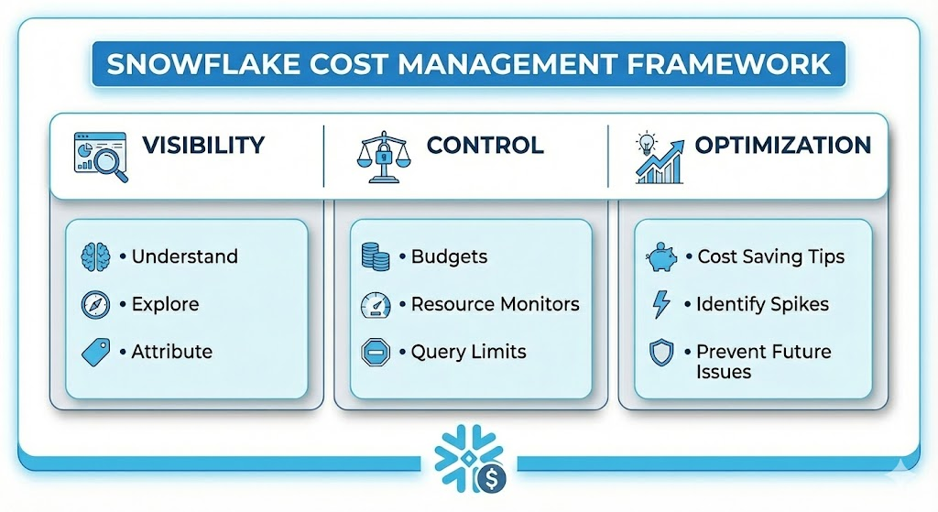
2.2: VISIBILITY
Gain transparency into where and how your money is being spent.
Step | Goal | Action
1. Understand | Learn cost basics | Study billing models & usage types,  Understand Snowflake billing model  Know compute, storage, and data transfer costs
2. Explore | View current spend | Use Snowsight dashboards & SQL queries
3. Attribute | Identify owners | Tag costs to specific teams/projects  Assign cost to teams or projects

2.3 CONTROL
Control means setting limits and rules so Snowflake costs do not go beyond the budget.
Control Tools Comparison
Tool | Scope / What it Controls | Best For
Budgets | Serverless features AND Warehouses | Account-level spending caps & alerts
Resource Monitors | Warehouses ONLY | Limiting specific compute clusters
Query Limits | Individual Queries | Killing "runaway" queries automatically
Budgets are used to monitor total spending and send alerts.
2.4 OPTIMIZATION:
Identify inefficiencies to reduce overall costs.
- Recommendations: Receive automated suggestions to downsize or suspend resources.
Recommendations help choose the right warehouse size and stop unused resources.
- Anomaly Detection: Spot sudden, unexpected cost spikes.
- Investigation: Drill down into usage patterns to prevent future waste.
--------------------------------------------------------------------------------------------------------------------------
3.Understanding Snowflake Costs
Overview
Snowflake follows a pay-per-use pricing model with three main cost component
You pay only for what you use, and costs come from three main areas:
- Compute
- Storage
- Data Transfer

3.1. Compute Cost
Cost incurred when running queries and processing data
Factor | Description
Warehouse Size | XS, S, M, L, XL → larger = more credits/hour
Runtime | Billed per-second (60-second minimum)
Concurrency | Multiple queries = longer active time
- Use auto-suspend (set to 1-5 mins)
- Right-size warehouses
- Use resource monitors

3.2 Storage Cost
Cost for data stored in Snowflake , charged monthly.
Storage Type | Description
Active Storage | Current tables & databases
Time Travel | Historical data (1-90 days)
Fail-safe | Recovery data (7 days, non-configurable)
- Drop unused tables
- Set lower Time Travel retention
- Use transient/temporary tables
3.3 Data Transfer Cost
Cost for moving data out of Snowflake
Transfer Type | Cost
Within same region | Free
Cross-region | Charged
Cross-cloud | Charged
Reduce approach:
- Keep data and consumers in same region
- Minimize external exports
- Use data sharing (no transfer cost)

Charged:
Component | Charged By
Compute | Credits per second
Storage | TB per month
Data Transfer | GB transferred out

4.Access Control for Cost Management:
Snowflake provides system-defined roles (roles, application roles, database roles) to control access to cost management features.
Access control decides who can see Snowflake costs and who can control or manage them.
Organization-Level Cost Access:
You can view org-level cost data from:
Account Type | Access
Organization Account | ✅ Yes
Regular Account with ORGADMIN enabled | ✅ Yes
Regular Account without ORGADMIN | ❌ No

Viewing Currency (Instead of Credits)
To see costs in currency (and view contract balance):
Requirement | Details
Account | Org account OR account with ORGADMIN enabled
Role | ACCOUNTADMIN, GLOBALORGADMIN, or ORGANIZATION_BILLING_VIEWER

Default Admin Access
Account Type | Role to Use
Organization Account | GLOBALORGADMIN
Regular Account | ACCOUNTADMIN

Granting Access to Users
Two Access Levels
Level | Application Role | Database Role
Viewer | APP_USAGE_VIEWER | USAGE_VIEWER
Administrator | APP_USAGE_ADMIN | USAGE_ADMIN
💡 For currency view, also grant ORGANIZATION_BILLING_VIEWER
Example: Grant Viewer Access
SQL
USE ROLE ACCOUNTADMIN;
CREATE USER joe;
CREATE ROLE cost_viewer_role;
USE DATABASE SNOWFLAKE;
USE SCHEMA ACCOUNT_USAGE;
GRANT APPLICATION ROLE APP_USAGE_VIEWER TO ROLE cost_viewer_role;
GRANT DATABASE ROLE USAGE_VIEWER TO ROLE cost_viewer_role;
GRANT ROLE cost_viewer_role TO USER joe;

Administrator Tasks
Users with APP_USAGE_ADMIN + USAGE_ADMIN can:
Feature | Capabilities
Budgets | Activate/Deactivate, Modify spending limits, Modify notification emails, Mute notifications, Delete custom budgets
Cost Anomalies | Modify notification emails

Reference:
text
Viewer = APP_USAGE_VIEWER + USAGE_VIEWER we can access only cost
Admin = APP_USAGE_ADMIN + USAGE_ADMIN cost control and budget manage
Currency = + ORGANIZATION_BILLING_VIEWER -Billing Viewer

5.visibility:
5.1 Visibility (Know Your Spend)
Gain transparency into where your credits are going.
- Exploring Cost
  - What it is: The process of analyzing credit consumption over time.
  - How to use: Use the Snowsight Admin Dashboard for visual graphs or query the SNOWFLAKE.ACCOUNT_USAGE views (like WAREHOUSE_METERING_HISTORY) for granular data.
Understanding where your Snowflake credits are consumed.
SELECT
warehouse_name,SUM(credits_used) as total_credits,
DATE_TRUNC('month', start_time) as month
FROM SNOWFLAKE.ACCOUNT_USAGE.WAREHOUSE_METERING_HISTORY
GROUP BY warehouse_name, month
ORDER BY total_credits DESC;

  - Attributing Cost
  - What it is: Assigning costs to specific teams, environments, or projects (Chargeback/Showback).
  - Key Feature: Use Query Tags (ALTER SESSION SET QUERY_TAG = 'Marketing_ETL'). This allows you to group costs by business unit in your billing reports.
Assign costs to teams, projects, or departments.
-- Use tags for cost attribution
ALTER WAREHOUSE analytics_wh SET TAG cost_center = 'Marketing';

-- Query costs by tag
SELECT tag_value,SUM(credits_used) as credits
FROM SNOWFLAKE.ACCOUNT_USAGE.TAG_REFERENCES tr
JOIN SNOWFLAKE.ACCOUNT_USAGE.WAREHOUSE_METERING_HISTORY wmh
ON tr.object_name = wmh.warehouse_name
GROUP BY tag_value;
5.3 Cost Anomalies
  - What it is: An automated feature that detects unusual spikes in credit consumption.
  - Benefit: Snowflake monitors your historical usage patterns and sends an alert if spending deviates significantly, catching run-away queries early.
Detect unusual spending patterns automatically.
SELECT usage_date,credits_used,
AVG(credits_used) OVER (ORDER BY usage_date ROWS 7 PRECEDING) as avg_7day
FROM SNOWFLAKE.ACCOUNT_USAGE.METERING_DAILY_HISTORY
WHERE credits_used > (avg_7day * 2); -- 2x normal usage
6.Control (Limit Your Spend)
Mechanisms to ensure you do not exceed your financial limits.
6.1 Budgets (Newer Feature)
What it is: A higher-level monitor that groups multiple objects (warehouses, tables, pipes) into a "Budget."
Create a budget (via Snowsight UI or API)
-- Budgets track spending against defined limits
Key features:
Monthly/quarterly limits
Email alerts at thresholds (50%, 75%, 90%, 100%)
Account or object-level budgets
Action: Sets a spending limit for a specific time period and alerts you when projected usage is predicted to exceed that limit.
6.2 Resource Monitors
What it is: The "Hard Stop" mechanism.
Action: Assign a credit quota to a specific Warehouse or the whole Account. You can configure it to Suspend or Suspend Immediately when a percentage of the quota (e.g., 90%, 100%) is reached.
Enforce credit limits on warehouses.
-- Create resource monitor
CREATE RESOURCE MONITOR monthly_limit
WITH CREDIT_QUOTA = 1000
FREQUENCY = MONTHLY
START_TIMESTAMP = IMMEDIATELY
TRIGGERS ON 75 PERCENT DO NOTIFY ON 90 PERCENT DO NOTIFY ON 100 PERCENT DO SUSPEND;
-- Assign to warehouse
ALTER WAREHOUSE my_wh SET RESOURCE_MONITOR = monthly_limit;
Action | Effect
NOTIFY | Send alert only
SUSPEND | Stop warehouse, finish running queries
SUSPEND_IMMEDIATE | Stop warehouse immediately

6.3Cost Controls for Warehouses
Auto-Suspend: Always set this. It turns the warehouse off when idle. (Recommendation: ~60 seconds for Standard, slightly longer for Enterprise).
Statement Timeouts: Configure STATEMENT_TIMEOUT_IN_SECONDS to automatically kill "zombie" queries that run for hours due to user error.
-- Auto-suspend when idle
ALTER WAREHOUSE my_wh SET AUTO_SUSPEND = 60; -- seconds
-- Auto-resume when needed
ALTER WAREHOUSE my_wh SET AUTO_RESUME = TRUE;
-- Limit scaling
ALTER WAREHOUSE my_wh SET
MIN_CLUSTER_COUNT = 1
MAX_CLUSTER_COUNT = 3;
-- Set statement timeout
ALTER WAREHOUSE my_wh SET STATEMENT_TIMEOUT_IN_SECONDS = 3600;
7. Optimization (Reduce Your Spend)
Strategies to get the same performance for fewer credits.
  - Cost Insights
What it is: A section within Snowsight that provides actionable recommendations.
Examples: It identifies warehouses that run infrequently but rarely suspend, or identifies the most expensive queries running in your account.
Admin → Cost Management → Cost Insights
7.2 Optimizing Cloud Services
The 10% Rule: Snowflake gives you Cloud Services (compilation, metadata ops) for free up to 10% of your daily Compute usage.
Action: If your Cloud Services bill is high, look for "chatty" applications running thousands of small metadata queries (like SHOW TABLES) or complex query compilations, and batch them or simplify them.
-- Monitor cloud services ratio
SELECT usage_date, credits_used_compute, credits_used_cloud_services,
(credits_used_cloud_services / credits_used_compute) * 100 as cs_ratio
FROM SNOWFLAKE.ACCOUNT_USAGE.METERING_DAILY_HISTORY
WHERE cs_ratio > 10;

Snowflake Billing Management

Overview
Snowflake provides robust billing management capabilities that allow organizations to monitor consumption, manage costs, and maintain financial control over their cloud data platform usage. Understanding these features is essential for financial accountability and cost optimization.
1. Accessing Usage Statements
What Are Usage Statements?
Usage statements provide detailed breakdowns of your Snowflake consumption, including compute credits, storage costs, and data transfer charges. These statements help organizations understand spending patterns and optimize resource allocation.
How to Access Usage Statements
Via Snowsight (Web Interface):
- Log in to Snowsight with an ACCOUNTADMIN or ORGADMIN role
- Navigate to Admin → Billing & Usage
- Select the Usage tab to view detailed consumption metrics
- Choose your date range (daily, weekly, monthly views available)
Via SQL Commands:
sql
-- View account usage
SELECT * FROM SNOWFLAKE.ACCOUNT_USAGE.METERING_HISTORY;

-- View warehouse usage
SELECT * FROM SNOWFLAKE.ACCOUNT_USAGE.WAREHOUSE_METERING_HISTORY;
Key Metrics Available
- Compute Credits: Virtual warehouse usage, cloud services consumption
- Storage Costs: Database storage, stage storage, fail-safe storage
- Data Transfer: Data egress charges between regions/clouds
- Serverless Features: Snowpipe, materialized views, search optimization
Export Options
- Download usage data as CSV or JSON formats
- Schedule automated reports via email
- Integrate with BI tools for custom dashboards
- Use REST APIs for programmatic access
2. Reconciling Usage Statements
- The Goal: verifying that the dollar amount on your invoice matches your actual data usage.
- How to check: Compare your PDF statement against Snowflake’s internal data views.
- Best Views to Use:
  - SNOWFLAKE.ORGANIZATION_USAGE.USAGE_IN_CURRENCY_DAILY: Shows daily cost in actual currency (USD).
  - SNOWFLAKE.ACCOUNT_USAGE.METERING_HISTORY: Shows credit consumption.
- The Formula: (Credits Used) $×$ (Contract Price per Credit) should equal your Usage Statement total.
3. Updating Billing contacts
- Where to go: Log in to Snowsight $→$ Admin $→$ Billing & Terms.
- The Action: Locate the "Bill To" or "Payment Method" section to edit contact details.
- Why it matters: Ensuring this is up-to-date guarantees that usage alerts and invoices are sent directly to your Finance or FinOps team, preventing service interruptions due to missed payments.
Types of Billing Notifications
- Monthly Invoices: Detailed billing statements
- Payment Reminders: Due date alerts
- Usage Alerts: Threshold breach notifications
- Credit Expiration: Advance warnings
- Contract Renewals: Upcoming renewal dates

